EXPLORE THE WORLD WITH SHEAFE’S FLAT BLUEBIRD
Due: Thursday, May 3, 2012
STUDENT NAME: ____________________________________________________ ROOM ___________

This week, I’m flying around the Sahara Desert. There are different types of deserts in the world. Did you know the Sahara Desert is the world’s largest hot desert? I think I told you last week that it stretches across Northern Africa, covering all or part of eleven countries. A desert gets very little rainfall and has extreme temperatures. That means it is scorching hot during the day and cold at night. Since it is dry in the desert, there is not a lot of plant and animal life. Different animals live in the different types of deserts. Animals that live in the desert have ways to deal with the lack of water, the extreme temperatures, and the shortage of food. To avoid daytime heat, many desert animals are nocturnal (that means they sleep during the day and come out at night to find food). Many desert animals do not have to drink at all; they get all the water they need from their food. Most desert animals are small.

Two of the animals that live in the Sahara Desert are the Fennec fox and the ostrich.

Color the pictures of these two animals by using the information given.

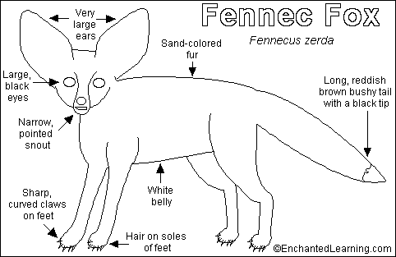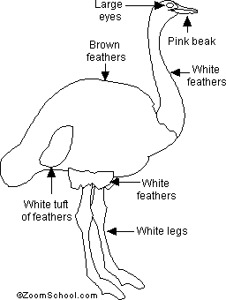

Ostrich

Looking for more of a challenge?
Turn the page over!

FENNEC FOX
The Fennec fox is a mammal that lives in sandy deserts. It has huge ears and very large eyes. Its ears help the fox lose extra heat and also helps it to hear its prey from a long distance away. The Fennec fox is nocturnal. It lives in a group.

The Fennec fox is the smallest fox. It measures from 14 to 17 inches long and weighs from 2 to 3 ½ pounds. It has a long, bushy tail, which helps it change direction quickly and keeps it warm when curls up to sleep. The fur of the Fennec fox is sand-colored and its belly is white.

The Fennec fox is an omnivore which means it eats both meat and plants. It gets most of the water it needs from its food. Female Fennec foxes give birth once a year to live babies called kits. Each litter has one to five kits.

OSTRICH
The ostrich is the largest and heaviest bird alive today. It can grow up to 9 feet tall and weigh up to 345 pounds. The ostrich has very big eyeballs. It has a long neck that helps it to see its prey from far away. The ostrich cannot fly, but it is the fastest-running bird today. Its feathers are black, white and brown.

Ostriches eat mostly plants, but also eat insects, fruits, seeds, nuts and some small animals. The ostrich gets most of its water from the food it eats. Ostriches lay eggs. The ostrich lays the biggest egg in the world, weighing about three pounds.

Using the information above, fill in the double-bubble map to tell the similarities and differences of these two animals.

Fennec
Fox

Ostrich

